DOWNLOAD AT sbaaz.org/adults-lead-the-way

COURSE 2 Applications are due Thurs, March 1, 2018
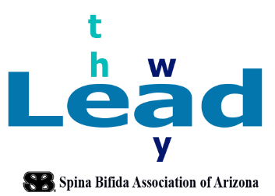
Participant Application
Lead the Way – Discover Your Passion and Influence Your Community

Full name of applicant: Birthdate: ___/___/_____
Street address: ____________________________________________________________________________
City and zip code: _________________________________________
Mailing address if different from above: ________________________________________________________
Phone number: Secondary phone: __________________________
How often do you check email? ________________________________
Email address: _______________________________________________________________

Do you consider yourself to be a “self-advocate”? yes no
Would you like to be more active in the disability community? yes no
What interest do you have that seems to be under engaged by people who are differently abled?

Have you ever been on a board of directors, panel or in a coalition? yes no
If yes, please identify the organization and your role:

Identify your typical methods of transportation: own transportation Bus taxi light rail personal driver
Identify devices you use: manual wheelchair power chair power scooter walker crutches
Do you use this device : ALWAYS or distance dependent

Do you have internet access at your home address? yes no
Do you have/own a computer for your personal use? yes no
Do you access the internet with a cell phone? yes no
Do you have use of a phone: landline personal cell

Are you currently working a job? yes no
If yes, would you be able to have off every other Tuesday until 2:00 beginning in January ?

Are you currently a student? yes no
If yes, please explain hours and days of the week

How would you get to 1001 E Fairmount Ave by 9:30 am on Tuesdays and depart at 12:30 to participate in the training?

If you complete the initial course sessions,
are you interested in applying as a mentor attendee for the second session? yes no
Session dates:
COURSE 1 - TUESDAYS 2018:
January 9 | January 23 | February 6 | February 20 | March 6 | March 20
COURSE 2 - TUESDAYS 2018:
April 3 | April 17 | May 1 | May 15 | May 29 | June 12

Please use extra space and tell us: (1,000 word limit for each question please- this can be INFORMAL!!)
1) why you would like to participate in this project.
2) what do you believe would help you to have the most success and positive experience?

